Data Operations - Storage

Definition
# Source: AI Source: Provided by: [Data Path: Persons Table -> ID Column: 1, Name_En Column: Motasem Essam] -> From: [Chatgpt (GPT‑5 Mini)] on [12/10/2025]
Storage is the process of saving and maintaining data in a system so it can be accessed and used later.
Data is stored in databases, files, or storage devices to ensure it is available for future retrieval, processing, and analysis.
Key idea:
Storage allows data to be kept safely and organized for later use.

Types of Data Storage

1️⃣ Database Storage
# Source: AI Source: Provided by: [Data Path: Persons Table -> ID Column: 1, Name_En Column: Motasem Essam] -> From: [Chatgpt (GPT‑5 Mini)] on [12/10/2025]
Definition:
Data is stored in a structured database system where it can be easily managed, searched, and updated.
Examples of database files:
- .accdb → Microsoft Access database
- .mdb → Older Microsoft Access database
- .sql → SQL database dump
- .db → SQLite database file
Example:

ID | Name | Score
1 | Ali | 85
2 | Sara | 90
3 | Omar | 80

2️⃣ File Storage
# Source: AI Source: Provided by: [Data Path: Persons Table -> ID Column: 1, Name_En Column: Motasem Essam] -> From: [Chatgpt (GPT‑5 Mini)] on [12/10/2025]
Definition:
Data is stored in files such as spreadsheets, text files, or documents.
Example:
- Excel files (.xlsx)
- Text files (.txt)
- CSV files (.csv)
Example table in a spreadsheet:
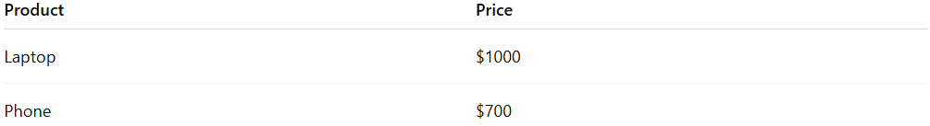
Product | Price
Laptop | $1000
Phone | $700

3️⃣ Cloud Storage ☁️
# Source: AI Source: Provided by: [Data Path: Persons Table -> ID Column: 1, Name_En Column: Motasem Essam] -> From: [Chatgpt (GPT‑5 Mini)] on [12/10/2025]
Definition:
Data is stored on remote servers accessible through the internet, allowing users to access data from different devices and locations.
Example:
- Storing company documents on cloud services
- Accessing shared files online

4️⃣ Physical Storage Devices 💾
# Source: AI Source: Provided by: [Data Path: Persons Table -> ID Column: 1, Name_En Column: Motasem Essam] -> From: [Chatgpt (GPT‑5 Mini)] on [12/10/2025]
Definition:
Data is stored on hardware devices that keep digital information.
Examples:
- Hard drives (HDD)
- Solid-state drives (SSD)
- USB flash drives
- Memory cards

Example
# Source: AI Source: Provided by: [Data Path: Persons Table -> ID Column: 1, Name_En Column: Motasem Essam] -> From: [Chatgpt (GPT‑5 Mini)] on [12/10/2025]
A school collects student test scores and stores them in a database.

Student | Score
Ali | 85
Sara | 90
Omar | 80
Because the data is saved for future access, this operation is called data storage.

Key Characteristics
# Source: AI Source: Provided by: [Data Path: Persons Table -> ID Column: 1, Name_En Column: Motasem Essam] -> From: [Chatgpt (GPT‑5 Mini)] on [12/10/2025]
- Keeps data safe and organized
- Allows future access and retrieval
- Supports data processing and analysis
- Can use databases, files, or storage devices

Advantages
# Source: AI Source: Provided by: [Data Path: Persons Table -> ID Column: 1, Name_En Column: Motasem Essam] -> From: [Chatgpt (GPT‑5 Mini)] on [12/10/2025]

- Allows data to be saved for future use
- Keeps data organized and structured
- Enables quick retrieval and analysis
- Supports backup and data security
- Allows sharing and collaboration (especially with cloud storage)

Disadvantages
# Source: AI Source: Provided by: [Data Path: Persons Table -> ID Column: 1, Name_En Column: Motasem Essam] -> From: [Chatgpt (GPT‑5 Mini)] on [12/10/2025]
- Requires storage space and infrastructure
- Data may be lost or corrupted if storage systems fail
- Security risks such as unauthorized access or hacking
- Maintenance and management costs for large storage systems

Summary
# Source: AI Source: Provided by: [Data Path: Persons Table -> ID Column: 1, Name_En Column: Motasem Essam] -> From: [Chatgpt (GPT‑5 Mini)] on [12/10/2025]
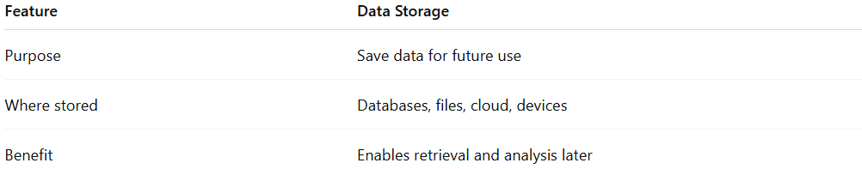
Feature | Data Storage
Purpose | Save data for future use
Where stored | Databases, files, cloud, devices
Benefit | Enables retrieval and analysis later

